ALL-AGES FUNDRAISING TOURNAMENT
To help improve the BSRC Wellness & Rec Center
Saturday, March 15 posted on SUG now!
This tournament will be teams, mixed or not, your choice.
Arrive by 9:00am, begin 9:30am
Cost $45 per person, payable in advance
Sign up as a team with both names on SUG first and then pay registration to BSRC by either cash in person or Venmo with your names and note “Tournament 3/15”.
1st and 2nd place prizes to include a private lesson for a team of two by Derek Winsor or by Pete Litchecsky.
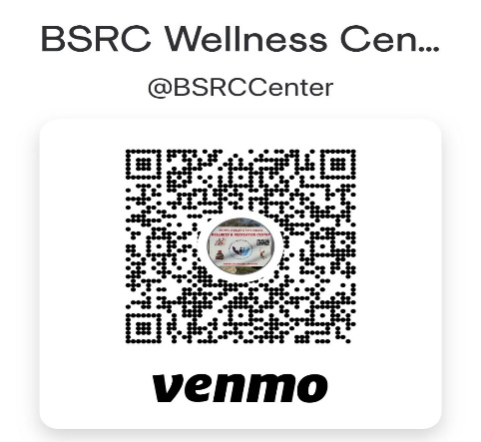

Sign-Up Genius

Spectators are welcome!

See next page for
Tournament Process
Tournament Process

- We will have a max of 24 players (12 teams of two). If more than that wish to play, or in the event of cancellations, we will start a waiting list. If you would like to play but don’t have a partner, sign up single on the waiting list. We might be able to get you in.
- We will assign a number to each team based solely on when you signed up. The tournament will consist of 3 games per team all played as doubles, each with a different assigned team.
- Each game will be played until the 1st team reaches 11 points, or until a maximum of 15 minutes. (No win by 2.)
- After the game, both teams report together to registration to have their scores recorded.
- Scoring will be as teams. Points will accrue for the 3 games. In the event of a top total score tie after 3 rounds, opposing scores will be deducted to determine winners.

